Armando Carrasquillo

2056125

**Individual Project 2**

**Introduction:**

The goal of this project is to train a multilayer perceptron that uses backpropagation. Once 3 sets are trained, the best one amongst them is picked to test the hit ratio. Afterwards the fault tolerance of the best set is tested by setting 20% of the weights to zero, and then tested again by setting another 20% of the weights to zero.

**Part 1: Multilayer Network with Backpropagation**

I trained different sets of weights using a multilayer network that has backpropagation. Parameters that were manipulated to get an ideal set of weights and bias (W1, W2, b1, and b2) were the number of hidden layers, the threshold (stopping criterion), and the alpha (adaptation rate). The results from the training includes a mean squared error and evolution of 5 of the weights/biases for each epoch displayed on a line graph. These trainings also have a max of 800 epochs.

The training occurs when running the tester script. The parameters are W1, W2, b1, b2, alp, PP, TT. W1, W2, b1, and b2 are the weights and bias respectively. They are created and set with a specific number of hidden layers. To create these weights and bias, and alp (the alpha/adaptation rate) the following code was used.

W1 = 0.25 * randn(10,20); W2 = 0.25 * randn(5,10);

b1 = 0.25 * randn(10,1); b2 = 0.25 * randn(5,1); alp = 0.1;

The PP is the patterns from the previous coding assignment, and TT is the targets that are used to train the weights.

Set 1: Best

Threshold: 0.0001, Hidden Layers: 10, Alpha: 0.1

I decided to use the default values that the assignment provided except for a lower threshold in order to get over 150 Epochs. The results show that the majority of the selected weights plateau which should show that it is well trained.

Avg Error:

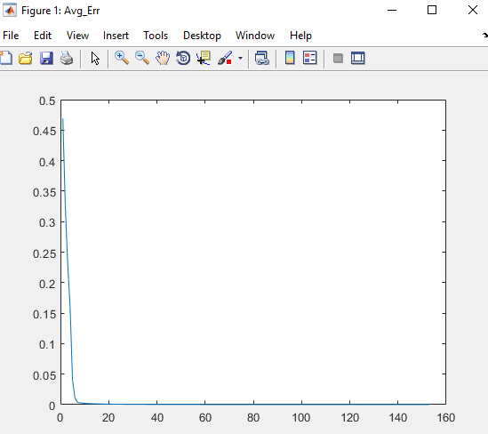

Trained Weights: W1 & W2

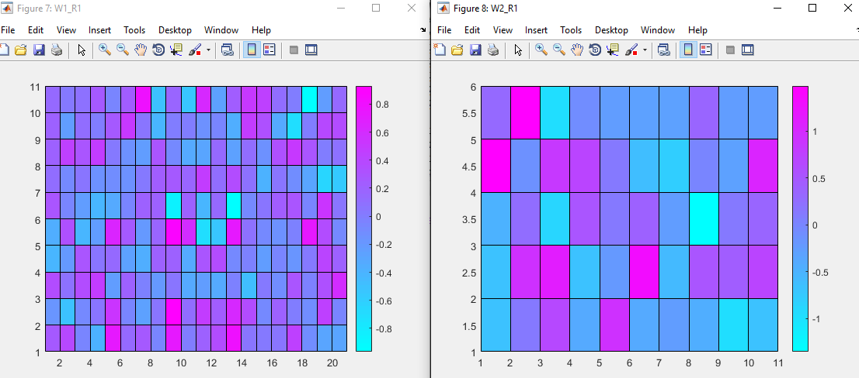

Evaluations from W1:

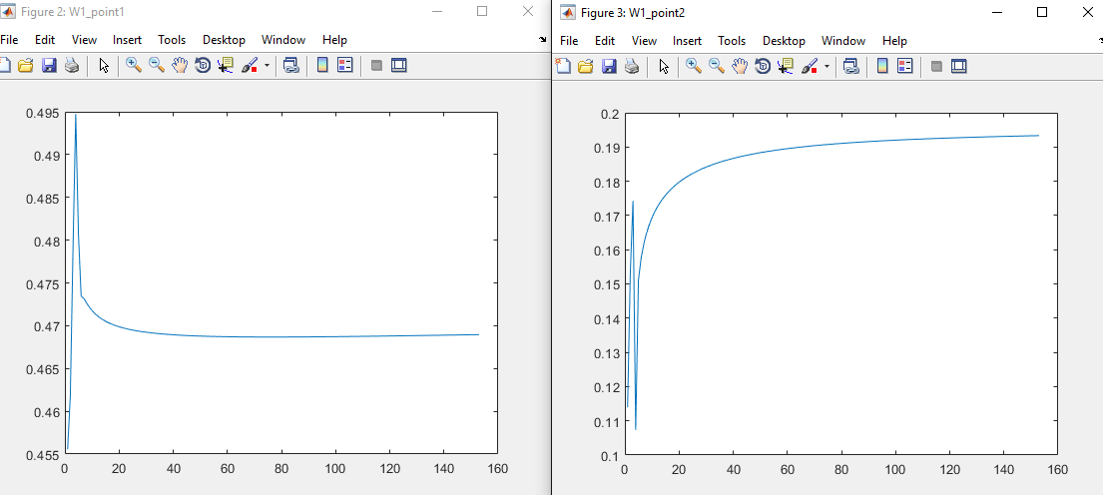

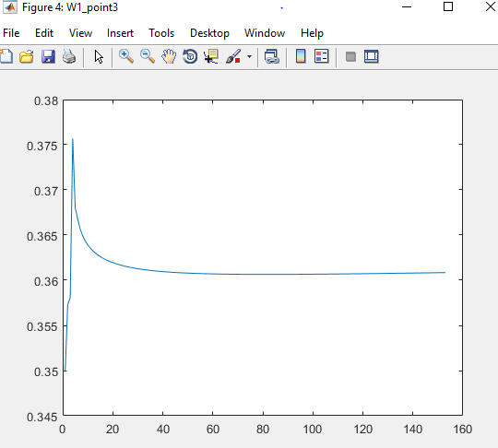

Evaluations from W2:

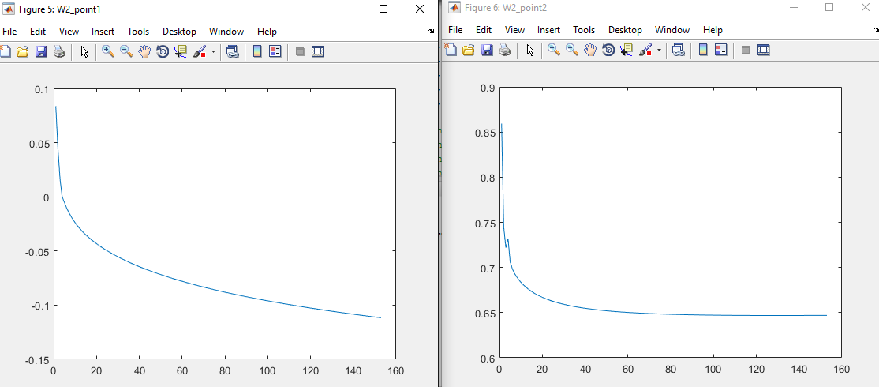

Set 2: Intermediate

Threshold: 0.00001 , Hidden Layers: 30 , Alpha: 0.01

I increased the number of hidden layers and decreased the threshold to try to get a more stable training that lasts more epochs. Unfortunately, the selected weights did not plateau which means that it would either require a lower threshold or a larger alpha to fully train. Even with the weights not plateauing, the average error shows that the threshold was met. Making this the intermediate set.

Avg Error:

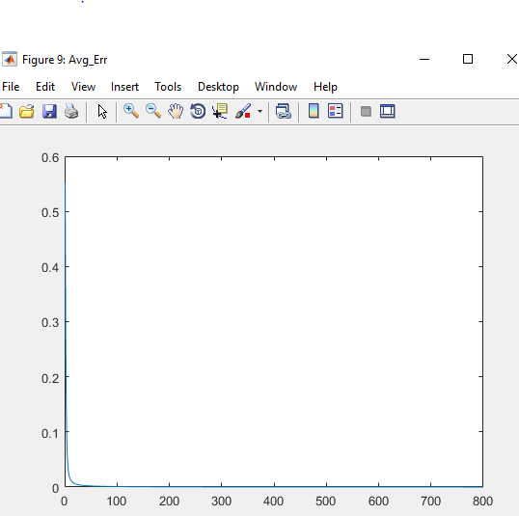

Trained Weights: W1 & W2

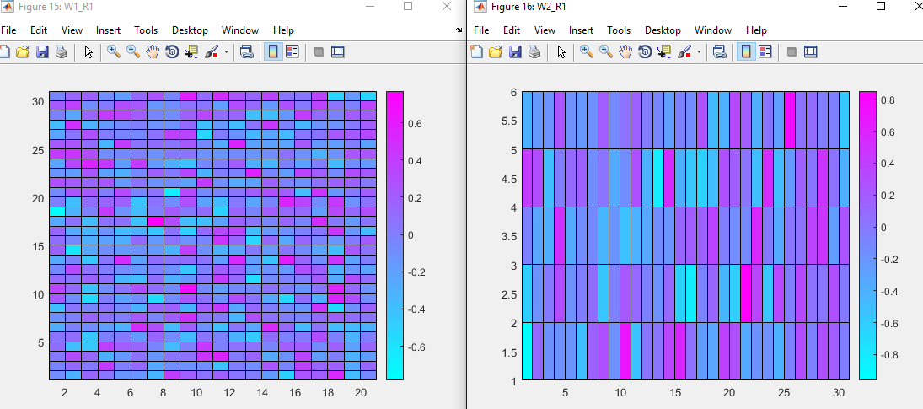

Evaluations from W1:

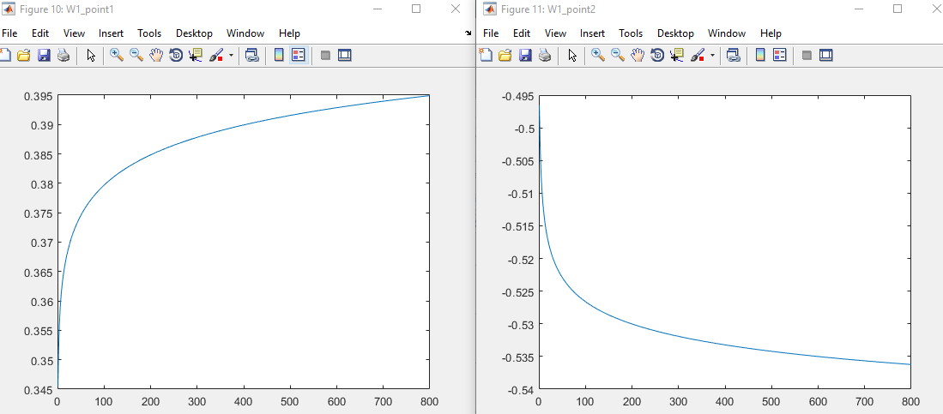

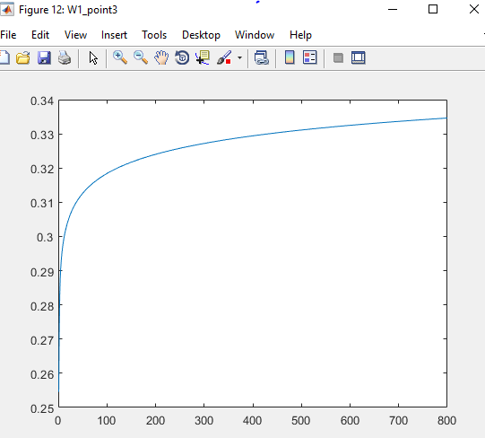

Evaluations from W2:

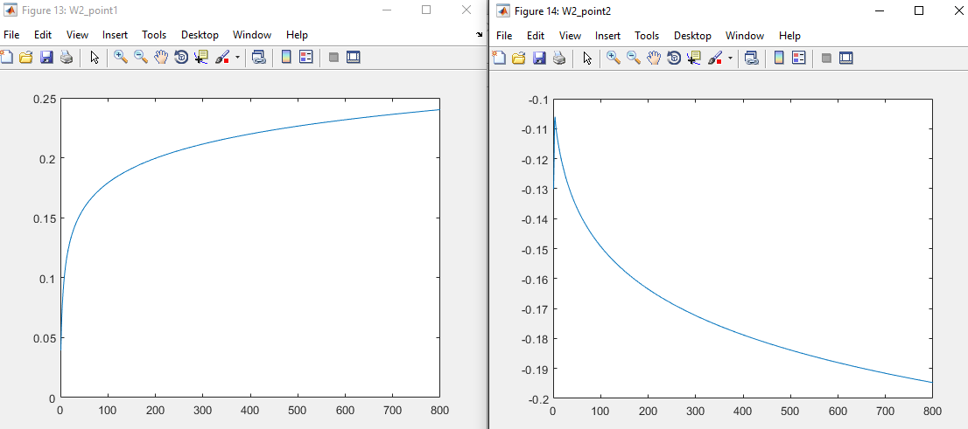

Set 3: Worst

Threshold: 0.00001, Hidden Layers: 20, Alpha: 0.2

I decreased the number of layers to 20 from 30 and increased with to get a better trained weights. Unfortunately, the randomly generated initial weights did not provide good train within 800 epochs. The threshold was never reached with this training which would mean that it should have the lowest hit ratio from the training sessions. Even though some of the weights plateaued, the average error shows that this is the WORST set.

Avg Error:

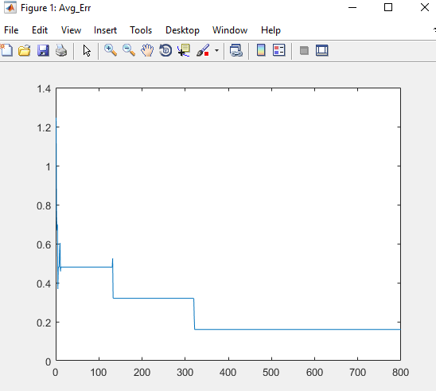

Trained Weights: W1 & W2

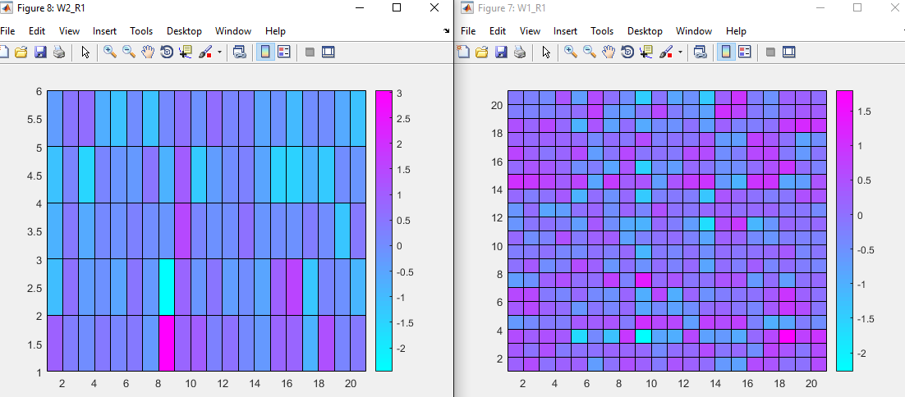

Evaluations from W1:

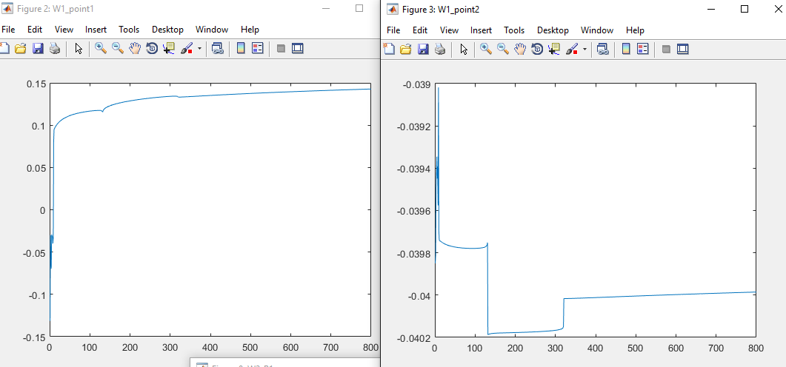

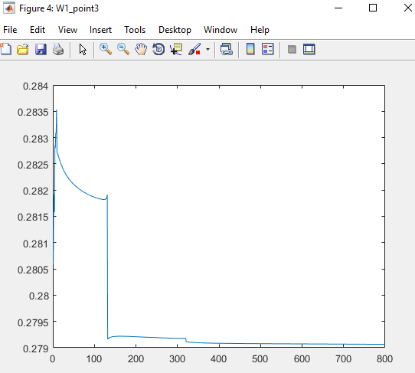

Evaluations from W2:

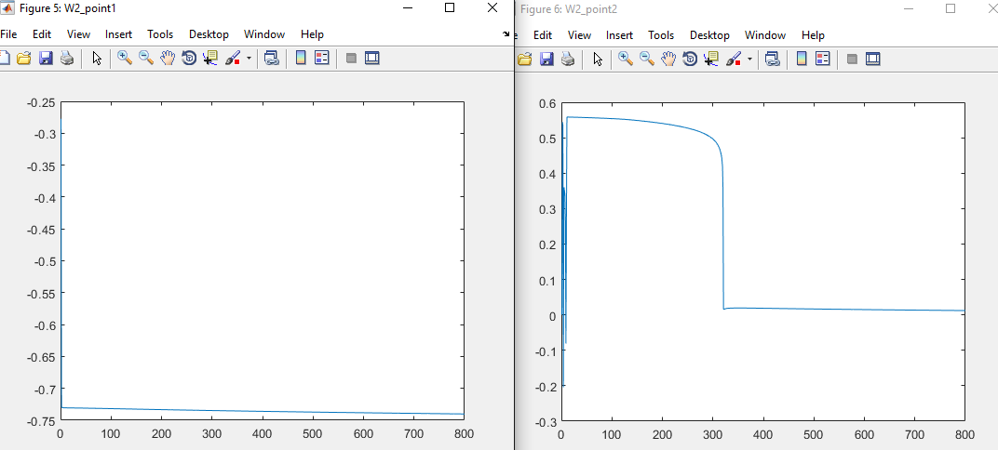

BEST Training set Hit Ratios

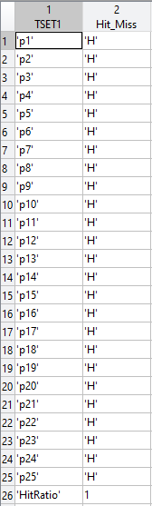 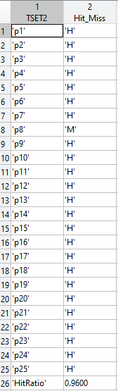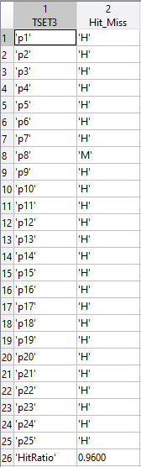

**Comments:**

The random values for the weights, the number of hidden layers, the threshold, and the alpha all contributed to how successful a training set is. The weights with higher number of hidden layers, the more beneficial a higher alpha would be. The lower the threshold, the more epochs a training session will likely require to reach the threshold. Among the sets chosen, set 1 had the most plateauing among the selected weights, and reached the threshold within the max number of epochs. This set also reached the designated threshold within the maximum allotted epochs. For these reasons is why it was selected as the BEST set, the set did not disappoint since it also had a high hit ratio among TSET1, TSET2, and TSET3. Set 1 also had a much higher hit ratio than the other two sets. When being tested against TSET3, the other two sets achieved a hit ratio of .76, and .72 respectively, showing that set 1 is indeed the better one of the three.

**Part 2: Fault Tolerance**

To test the fault tolerance of the BEST set, 20% of the trained weights and bias are set to zero. With these altered weights and bias, they are tested against TSET1, TSET2, and TSET3 to see how their hit ratios perform. Afterwards, this is repeated with an additional 20% of the weights being set to zero.

1. **20% of the trained weights and bias set to zero**

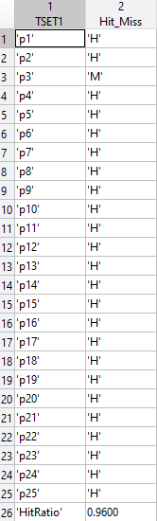 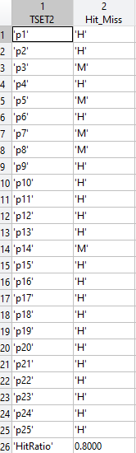 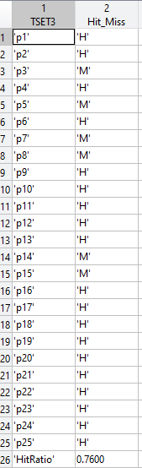

1. **40% of the trained weights and bias set to zero**

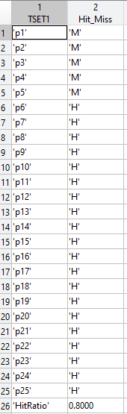 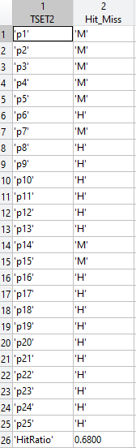 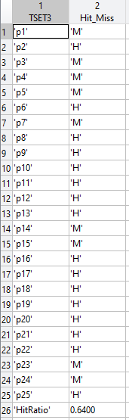

**Comments:**

The results from the fault tolerance showed that the hit ratio for the 20% set was lower than the hit ratio from the original tests. The hit ratio for the 40% set was also lower than the hit ratio for the 20% set. This is the expected result since the trained weights and bias are destroyed, thus decreasing their effectiveness.